ASSIGNMENT-3

|  |  |
| --- | --- |
| AssignmentDate | 30September2022 |
| StudentName | R.Deepa |
| StudentRollNumber | 962719106007 |
| MaximumMarks | 2Marks |

# DownloadtheDataset

Link:<https://drive.google.com/file/d/1zZ87e7GDpN90-Sa_AKbvMm3EEfQkEQ_R/view>

# Image AugmentationSolution:

pwd

fromtensorflow.keras.preprocessing.imageimport ImageDataGeneratortrain_datagen=ImageDataGenerator(rescale=1./255,zoom_range=0.2,horizontal_flip=True,vertical_flip=False)

test_datagen=ImageDataGenerator(rescale=1./255)ls

pwdx_train=train_datagen.flow_from_directory(r"/content/drive/MyDrive/flowers",target_size=(64,64),

class_mode='categorical',batch_size=24)x_test=test_datagen.flow_from_directory(r"/content/drive/MyDrive/flowers",target_size=(64,64),

class_mode='categorical',batch_size=24)

x_train.class_indices

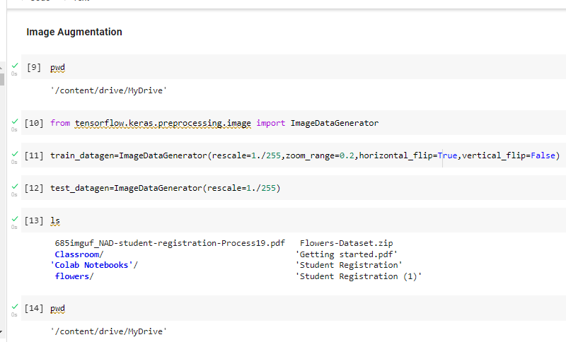

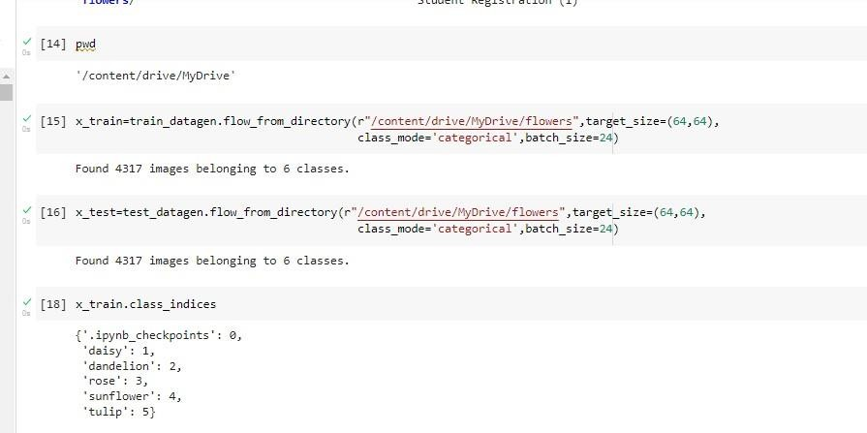

# Create ModelSolution:

pwdls

fromgoogle.colabimportdrivedrive.mount('/content/drive')cd/content/drive/MyDrive

!unzipFlowers-Dataset.zip

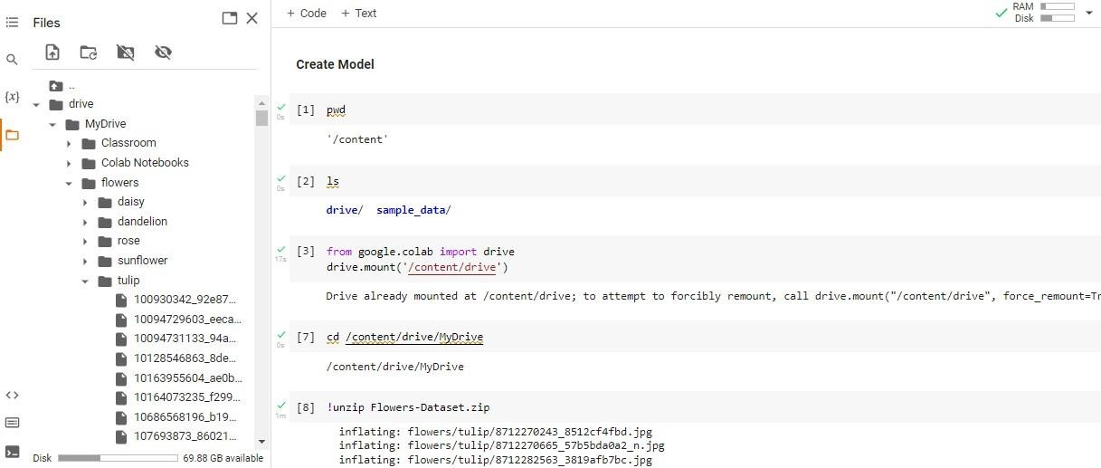

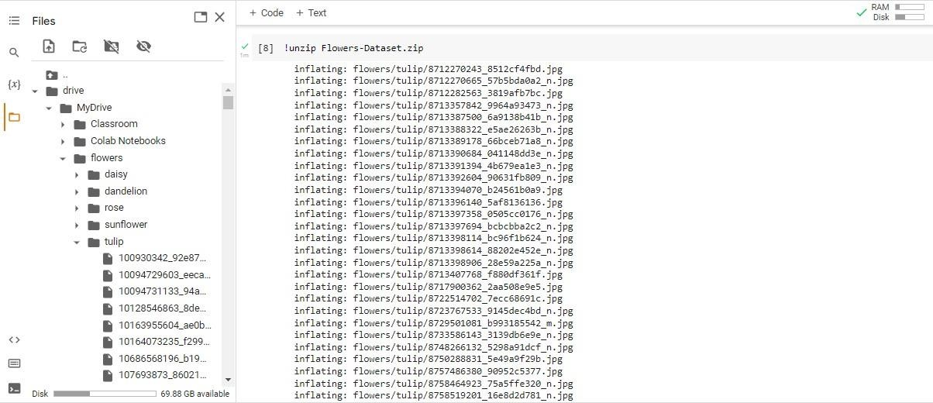

# AddLayers(Convolution,Maxpooling,Flatten,Dense-(HiddenLayers),Output)Solution:

fromtensorflow.keras.modelsimportSequential

from tensorflow.keras.layersimport Dense,Convolution2D,MaxPooling2D,Flattenmodel=Sequential()model.add(Convolution2D(32,(3,3),input_shape=(64,64,3),activation='relu'))model.add(MaxPooling2D(pool_size=(2,2)))

model.add(Flatten())model.summary()32*(3*3*3+1)

# Hiddenlayer

model.add(Dense(300,activation='relu'))model.add(Dense(150,activation='relu'))

# Outputlayer

model.add(Dense(4,activation='softmax'))

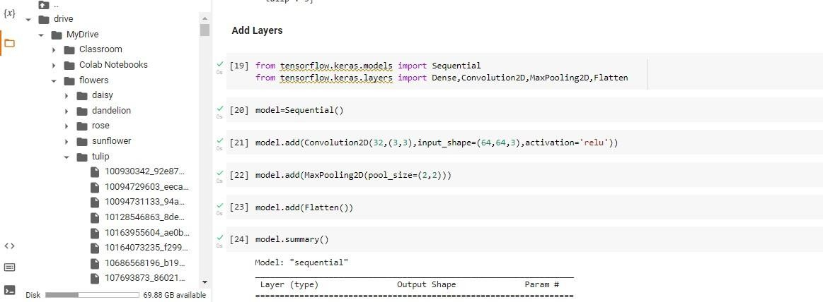

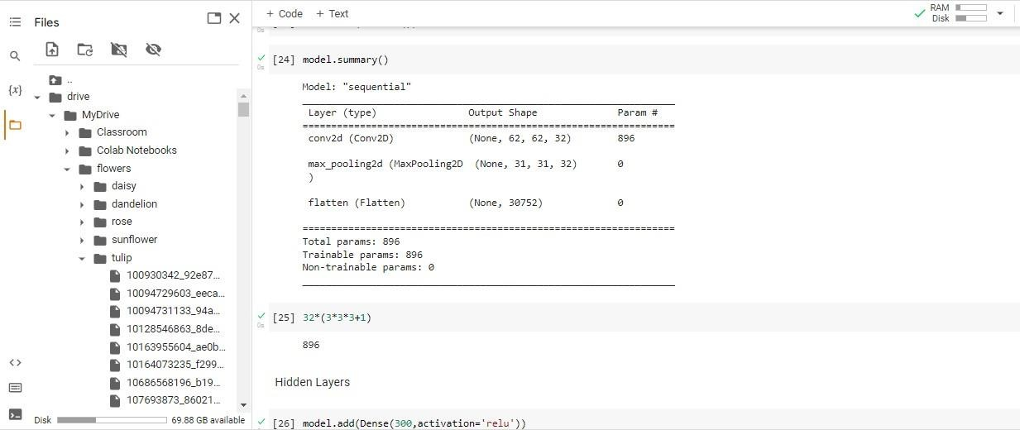

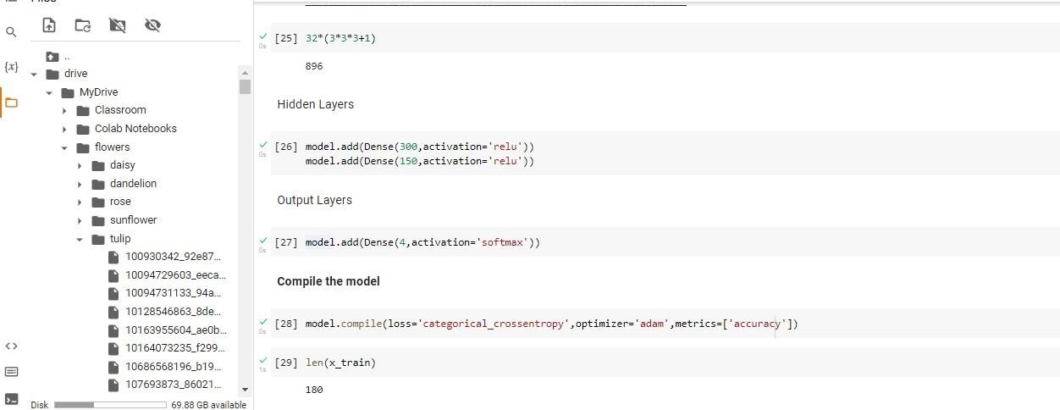

# Compile The ModelSolution:

model.compile(loss='categorical_crossentropy',optimizer='adam',metrics=['accuracy'])len(x_train)

1238/24

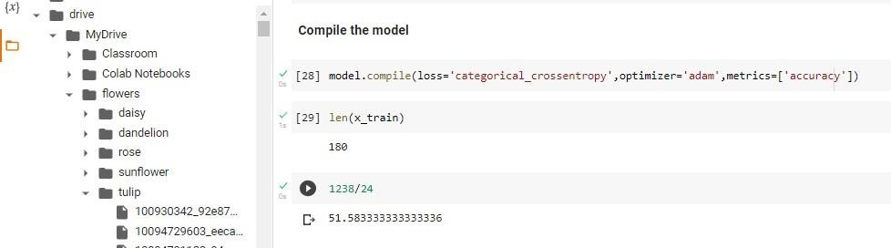

# FitTheModelSolution:

importnumpyasnp

fromsklearn.linear_modelimportLinearRegressionx=30*np.random.random((20,1))y=0.5*x+1.0+np.random.normal(size=x.shape)model=LinearRegression()

model.fit(x,y)x_new=np.linspace(0,30,100)y_new=model.predict(x_new[:,np.newaxis])

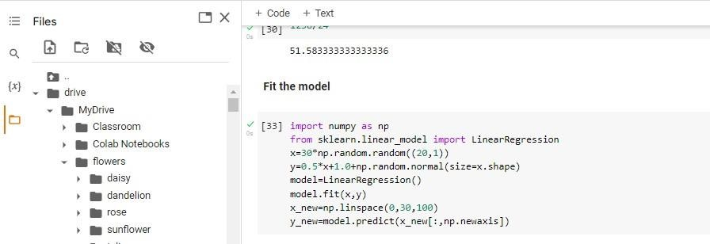

# Save The ModelSolution:

Lsmodel.save('flower.h5')ls

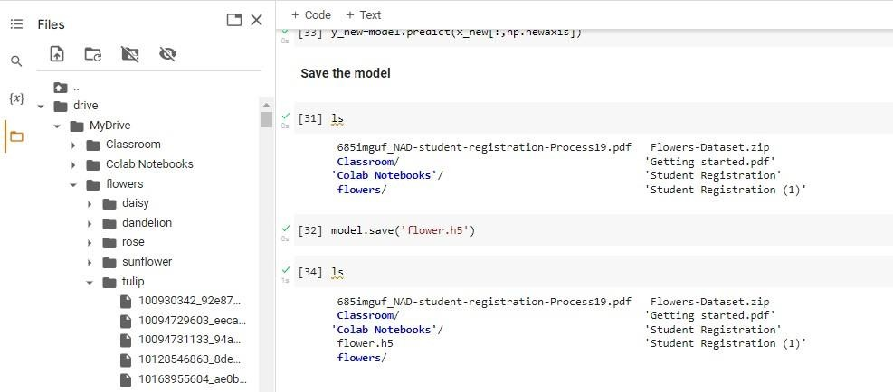

# Test The ModelSolution:

importnumpyasnp

fromtensorflow.keras.modelsimport load_modelfromtensorflow.keras.preprocessingimportimage#loadthemodel

model=load_model('flower.h5')img=image.load_img(r"/content/drive/MyDrive/flowers/rose/10503217854_e66a804309.jpg")imgimg=image.load_img(r"/content/drive/MyDrive/flowers/rose/10503217854_e66a804309.jpg",target_size=(64,64))

imgx=image.img_to_array(img)xx=np.expand_dims(x,axis=0)x

y=np.argmax(model.predict(x),axis=1)y

x_train.class_indicesindex=['daisy','dandelion','rose','sunflower','tulip']index[y[0]]

img=image.load_img(r"/content/drive/MyDrive/flowers/daisy/100080576_f52e8ee070_n.jpg",target_size=(64,64))

x=image.img_to_array(img)x=np.expand_dims(x,axis=0)y=np.argmax(model.predict(x),axis=1)

index=['daisy','dandelion','rose','sunflower','tulip']index[y[0]]

img=image.load_img(r"/content/drive/MyDrive/flowers/dandelion/10043234166_e6dd915111_n

.jpg",target_size=(64,64))

x=image.img_to_array(img)x=np.expand_dims(x,axis=0)y=np.argmax(model.predict(x),axis=1)

index=['daisy','dandelion','rose','sunflower','tulip']index[y[0]]

img=image.load_img(r"/content/drive/MyDrive/flowers/rose/10090824183_d02c613f10_m.jpg"

,target_size=(64,64))x=image.img_to_array(img)x=np.expand_dims(x,axis=0)y=np.argmax(model.predict(x),axis=1)

index=['daisy','dandelion','rose','sunflower','tulip']index[y[0]]

img=image.load_img(r"/content/drive/MyDrive/flowers/sunflower/1008566138_6927679c8a.jpg",target_size=(64,64))

x=image.img_to_array(img)x=np.expand_dims(x,axis=0)y=np.argmax(model.predict(x),axis=1)

index=['daisy','dandelion','rose','sunflower','tulip']index[y[0]]

img=image.load_img(r"/content/drive/MyDrive/flowers/tulip/100930342_92e8746431_n.jpg",target_size=(64,64))

x=image.img_to_array(img)x=np.expand_dims(x,axis=0)y=np.argmax(model.predict(x),axis=1)

index=['daisy','dandelion','rose','sunflower','tulip']index[y[0]]

